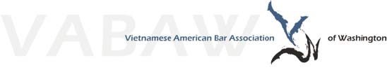

VABAW MENTEE APPLICATION FORM 2020
Thank you for agreeing to serve as a mentee in VABAW’s 2019 Mentorship Program! Please complete this form and return by email to Nancy Pham at nancylypham@gmail.com by April 14, 2020.
CONTACT INFORMATION
Full Name:
Telephone:
Email:
BACKGROUND INFORMATION
I am a: (circle one)  Law Student  Year: 1L 2L 3L | Junior Practitioner  Years in practice: 1 2 3
College:
Employer:
Law school:
Practice area(s)/area(s) of interest:
General hobbies/interests:
Preferences in mentor pairing: (Optional; e.g. gender, law school, practice area interest, etc.)
Additional comments: (Optional)

PLEASE RETURN COMPLETED FORM TO NANCYLYPHAM@GMAIL.COM.

